Feelings Helper Younger children
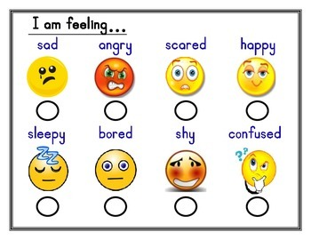
Silly ___
Embarrassed ___
Lonely ___
Excited ___
Hungry ___
Uncomfortable ___
Focused ___
Interested ___
I feel _______________________and____________________________
I feel this way because ________________________________________________________________________________________________________________________________________________________________________________________________________________________
I want to feel ______________________________________________________
I plan to ____________________________________________________________________________________________________________
Do you need help to follow your plan? Circle: Yes No Maybe
Did your plan work? Circle: Yes No A little

